CSI-2300 Winter 2025

Yasin Kone

Chidi Dike

This is a Java based application made using javafx. It is an app that gives you a survey and based on that survey you get recommended different anime.

**Support**

[ykone@oakland.edu](mailto:ykone@oakland.edu)

[cdike@oakland.edu](mailto:cdike@oakland.edu)

**Prerequisites**

* Java JDK
* VS Code
* Javafx

1. **Launch the program**

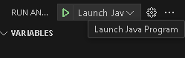

1. **Press “Start Survey” (use full screen full maximum optimization)**

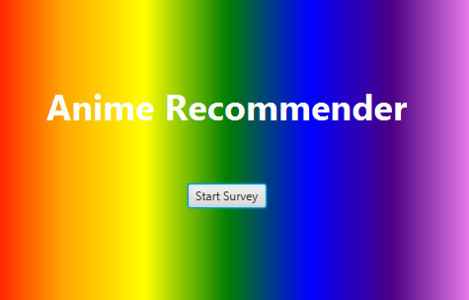

**3. Take the survey by selecting the boxes that interest you (question 3 is optional)**

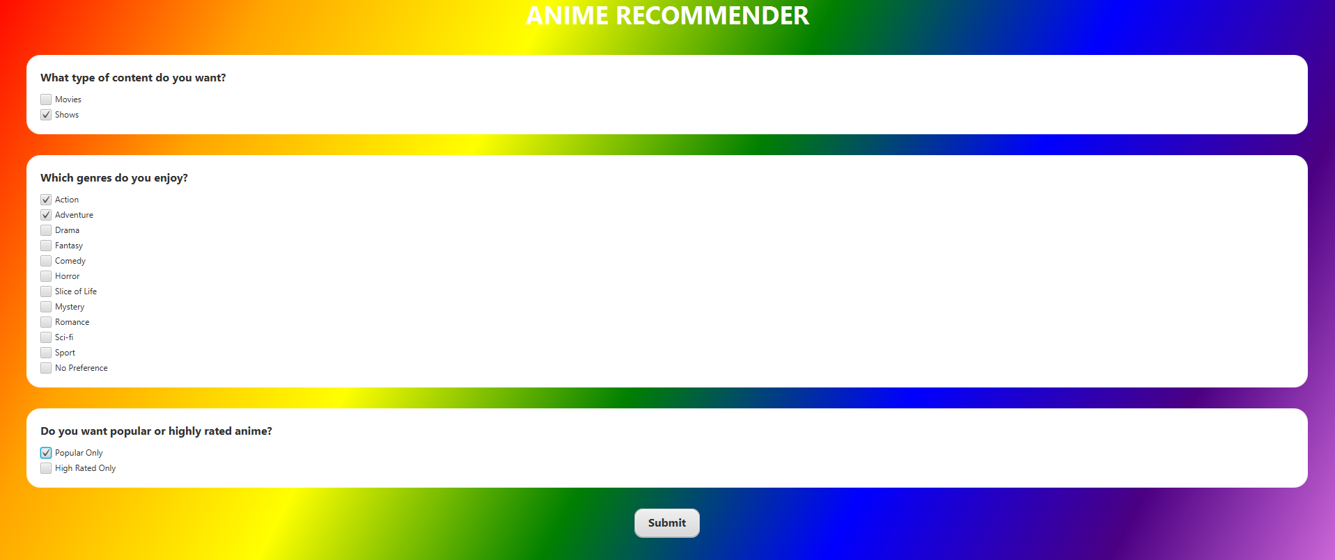

**4. Press submit**



**5. Get your results**

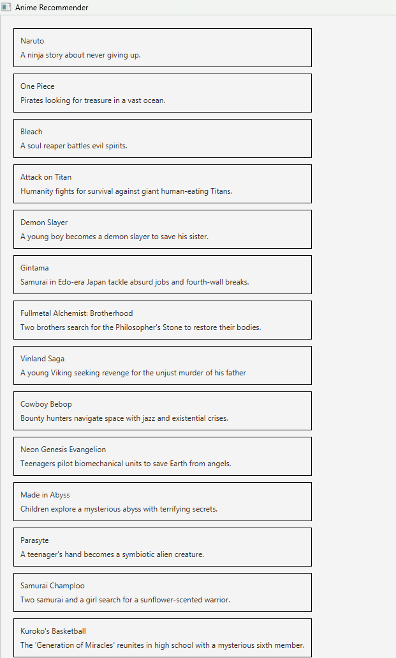

**6. Press “Back to Home” to retake it or exit out to quit**

